3rd FUTUREMED Transnational Stakeholder Platform Meeting

Civitavecchia (Italy), May 19th 2015

“Looking for soft measures to improve the accessibility to Med”

10:00 Registration

10:30 Welcome speech

10:40 – 11:00 Presentation of the topic “The maritime-railway intermodality:
a strategic tool for developing Mediterranean ports and for
re-balacing north-south traffic flows in Europe”

11:00 – 11:30 Introduction by key speakers

11:30 – 12:45 Round table discussion

12:45 - 13:00: Conclusions by key speakers and moderator

www.futuremedproject.eu

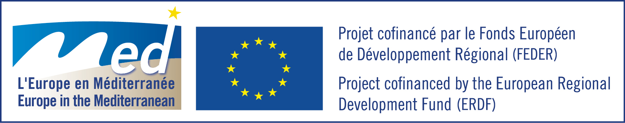

3rd FUTUREMED OBSERVATORY – GEIE WORKSHOP

Civitavecchia (Italy), May 19th 2015

AGENDA

14:30 - 15:00 The FUTUREMED OBSERVATORY – GEIE. Aim and objectives.

15:00 - 15:30 Presentation of the FUTUREMED OBSERVATORY – GEIE legal
structure

15:30 – 16:30 Presentation of the road map for the Observatory implementation
and of the first set of objectives. Open discussion.

16:30 End of the 3rd Observatory workshop.

www.futuremedproject.eu

