ANNEX 2
Technical Datasheet – ePop-Zeb Demonstrator
Call “Open Energy Lab”

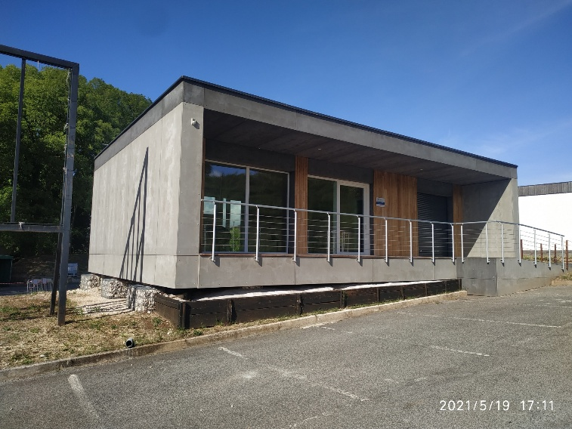 | 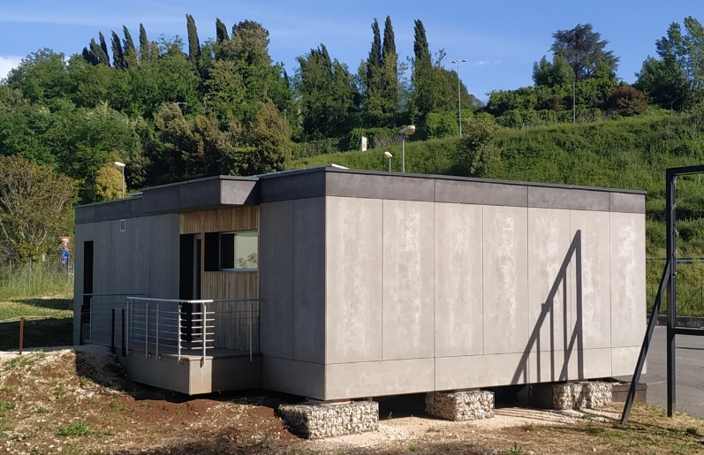

The ePop-Zeb demonstrator, installed at the Spazio Attivo Lazio Innova in Colleferro (Rome), serves as a real-world “living lab and demonstrator” for the green & smart building innovation ecosystem, within the networking and support environment for startups and SMEs that characterizes Spazio Attivo Lazio Innova.
Its role as a laboratory for experimenting, validating, and showcasing innovative solutions is part of the broader Open Innovation program implemented by the Lazio Innova Spazio Attivo Network under the RP ERDF Lazio 2021/2027 S.O. 1.3.

Technical Features
The ePop-ZEB is a laboratory-use building constructed to A4-plus energy class standards, featuring a modular, passive, disassemblable, reassemblable, and fully recyclable structure. It includes customizable interior and exterior finishes—such as windows, vertical and horizontal surfaces, lighting solutions, and solar shading—and offers high acoustic comfort, indoor air quality, and seismic resistance up to R7.
It generates an annual energy surplus, exceeding Zero Energy Building (ZEB) standards. Its low-consumption climate control system, combined with mechanical ventilation (VMC) and a photovoltaic system with storage, enables full tracking of the building’s energy balance from its inception, thanks to a complete BIM (Building Information Modeling) model. The demonstrator will also be developed toward the implementation of a Digital Twin system.
As is well known, a Digital Twin system is a highly innovative tool capable of monitoring, simulating, and controlling any object in real time. While these systems are now standard in high-value industries (e.g., aerospace, aviation, energy), they are still rare in the construction sector and are considered a new frontier for BMS (Building Management Systems).
Additionally, the module features a dry foundation system detached from the ground, consisting of metal gabions filled with coarse and varied-sized stones, within which threaded rods are secured by a base plate and a second top locking plate.
Ventilated walls have also been installed to prevent infiltration and stagnation within the building’s structural components.
The construction protocol adopted allows for the integration of systems within the building while ensuring a high degree of separability. This feature provides the building with a high level of resilience in terms of its technical installations. Due to the high insulation offered by the perimeter structures and the design based on bioclimatic principles, the structure can be fully considered a passive building.
For further information: Dimostratore ePop-Zeb - Spazio Attivo - LazioInnova

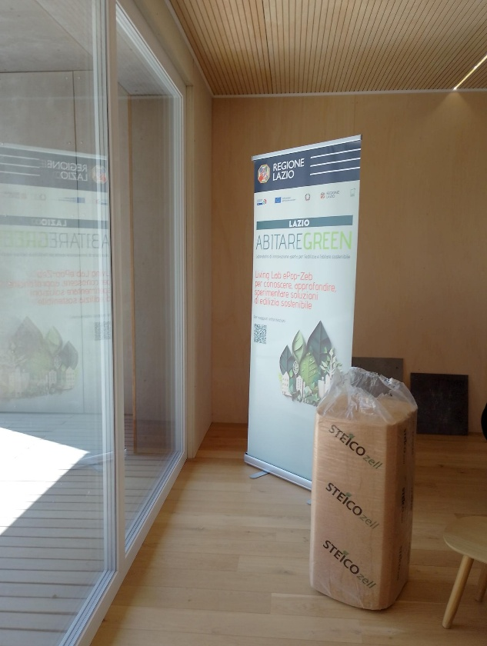 | 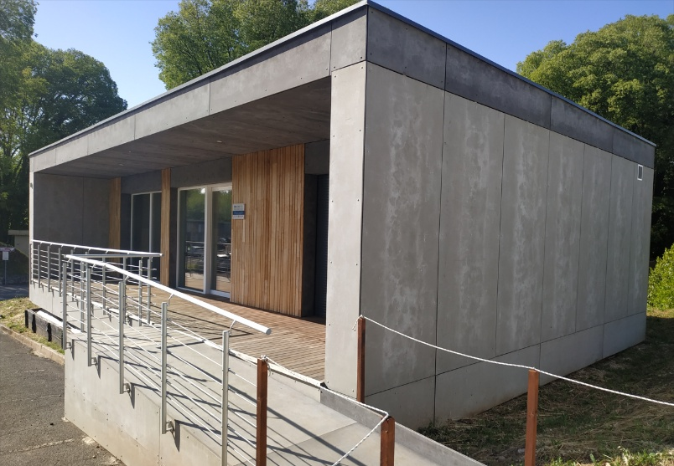
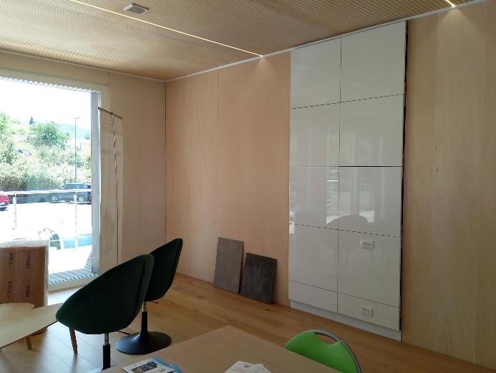 | 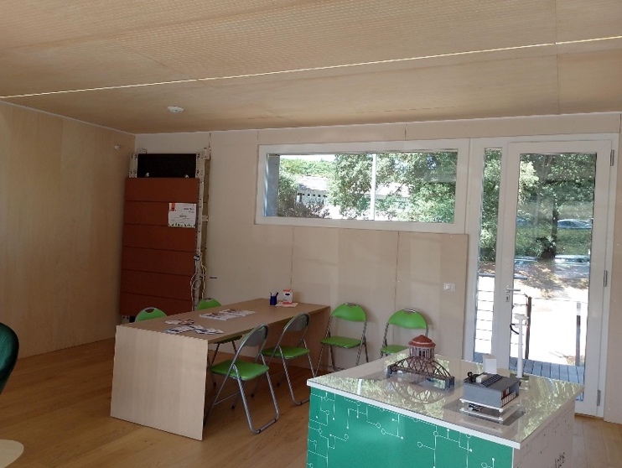

Candidate companies to the Call that are admitted to the Living Lab Action will be granted access to the digital File of the building

