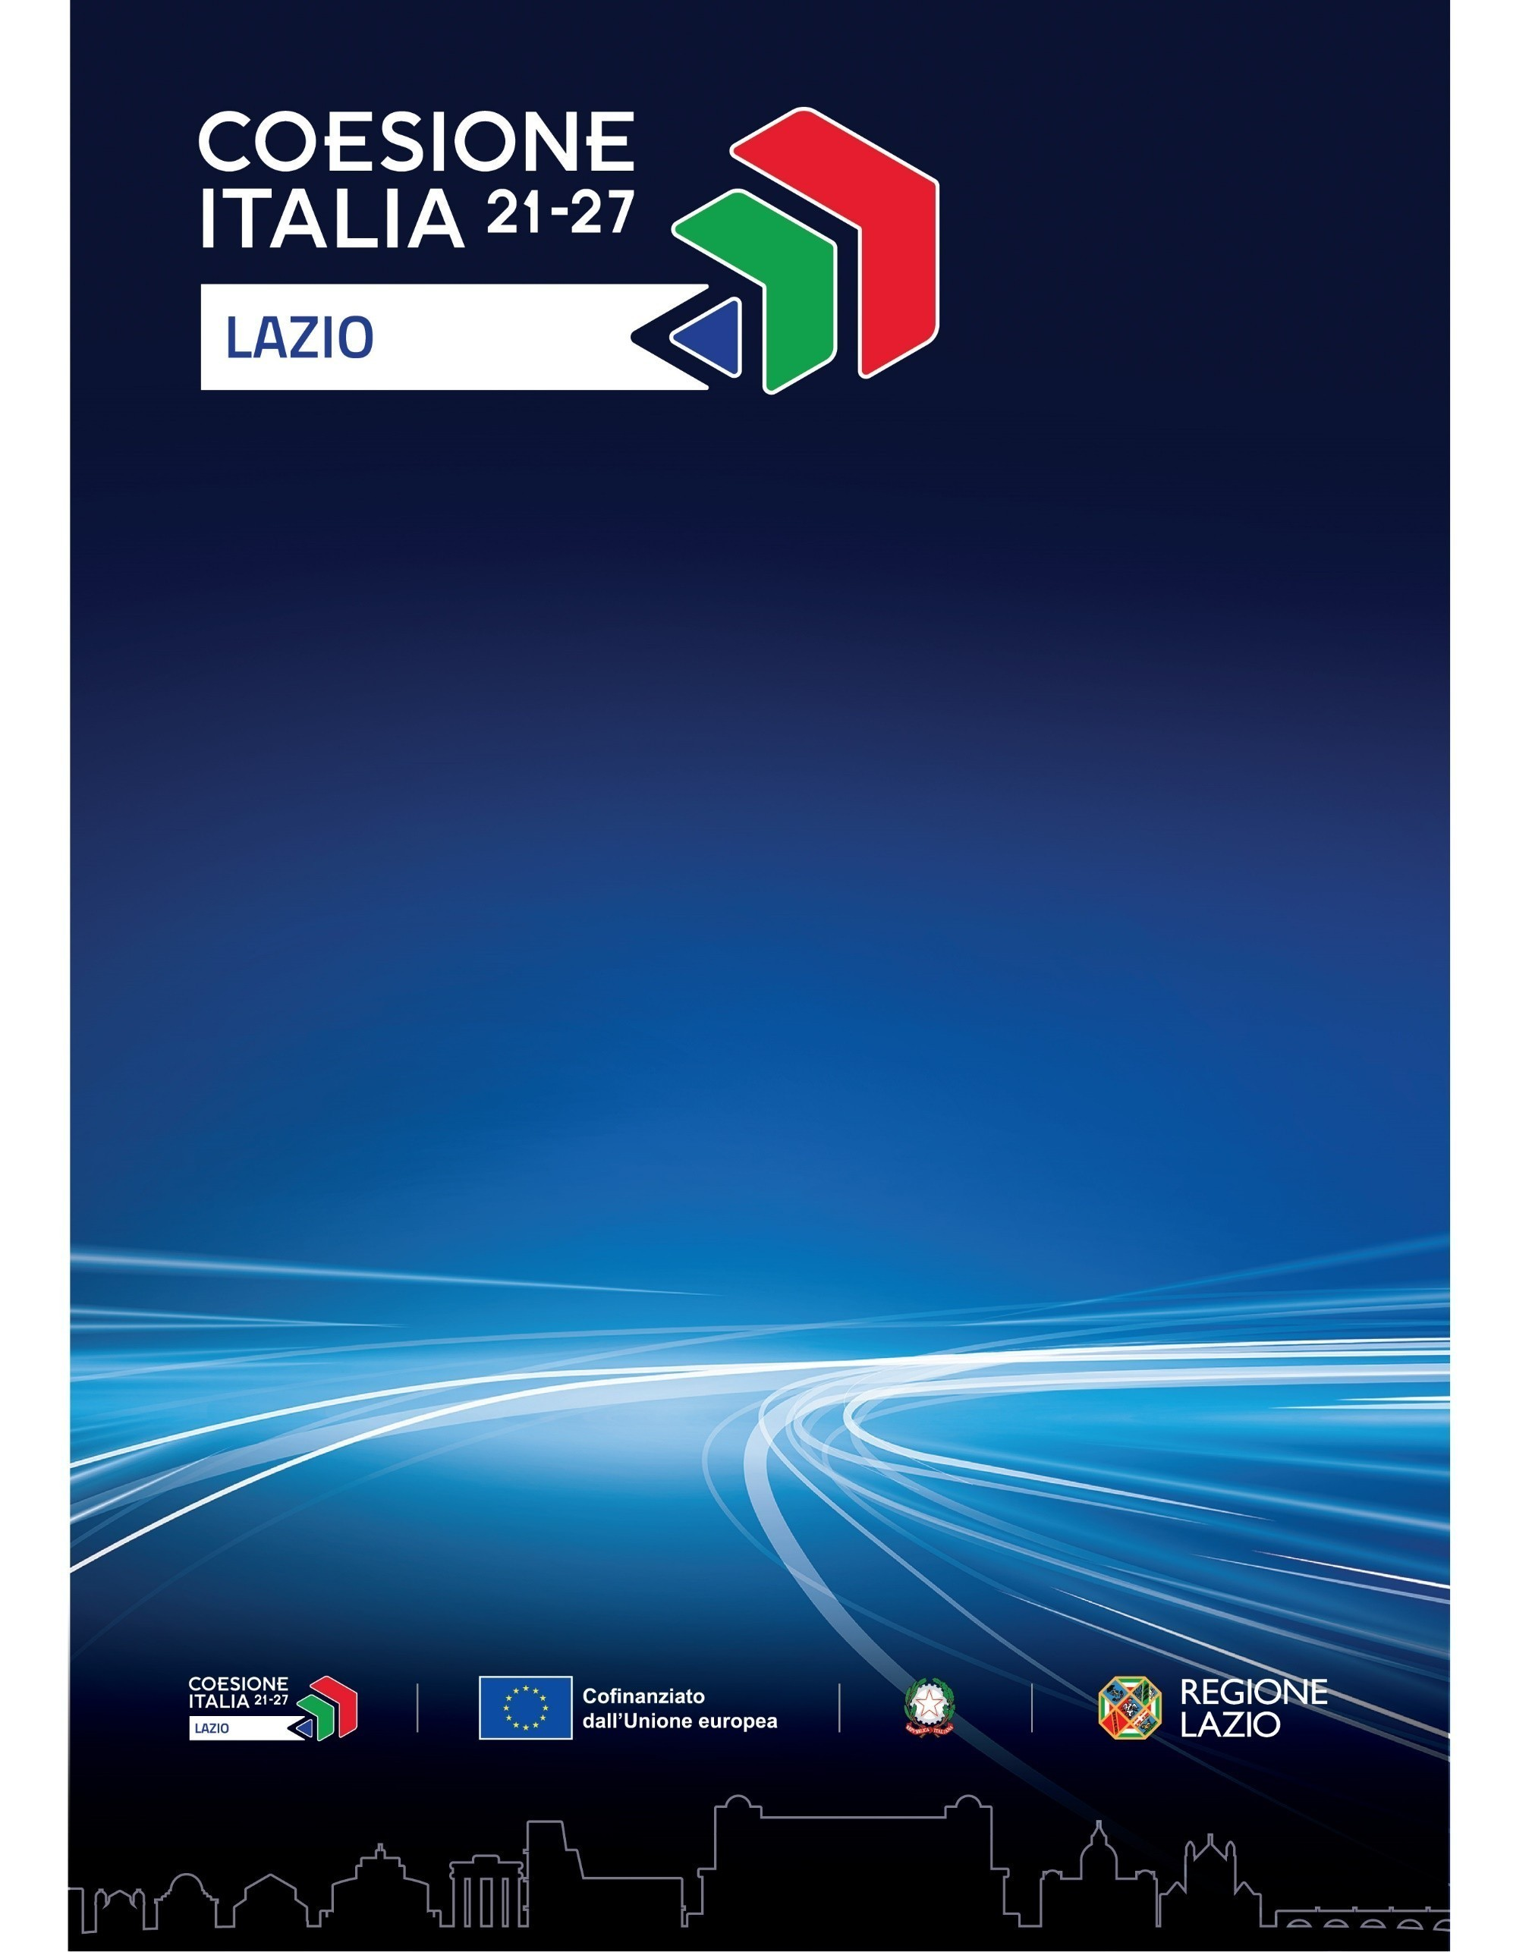

**CALL 4 INNOVATION**

**OPEN ENERGY LAB**

**Programma Regionale Lazio FESR 2021-2027**

**Obiettivo Specifico 1.3**

**Introduction**

As part of the Lazio Region’s project “Strengthening the Spazio Attivo Network”, under the Lazio RP ERDF Lazio 2021/2027 – Specific Objective 1.3 *Fostering sustainable growth and competitiveness of SMEs and the creation of jobs within SMEs, including through productive investments*, Lazio Innova, in collaboration with C.I.T.E.R.A. (Interdepartmental Research Center for Territory, Building, Restoration, Environment) of Sapienza University of Rome, InnovUp, and the National Technological Cluster (CTN) Energy – launches the *Call4Innovation* ***Open* *Energy Lab***, with the goal of supporting companies in **developing innovative solutions to tackle the main challenges related to the energy transition and smart building**.

This call is also part of a broader initiative implemented by Lazio Innova: the creation and launch of a *Living Lab* dedicated to the *green building* supply chain, called “Lazio Abitare Green”. The laboratory includes a dedicated demonstrator – an NZEB residential module named ePop-Zeb – developed to test and validate innovative solutions for the “*green & smart building sector*”. Energy-related challenges in the residential sector represent one of the main focus areas of the *Living Lab* (se the [Lazio Abitare Green](https://www.lazioinnova.it/innovazione-aperta/iniziativa/lazio-abitare-green) *Landing Page*).

1. **Objectives**

Through the Open Energy Lab call, Lazio Innova aims to:

* Highlight the main market challenges and identify innovative solutions and technologies, particularly in highly critical areas such as: *energy production, storage, and exchange; smart grids; e-mobility; CO₂ capture; circular economy and innovative materials for the energy transition (including solutions for efficient use of water resources); digital energy;*
* Promote collaboration among enterprises to accelerate the development of solutions and technologies, including through access to matchmaking platforms;
* Provide accessto **real-environment testing and prototyping spaces**, also through the distributed **FabLab** network of the Lazio Region, ensuring effective support during the experimentation and validation phases of the solutions developed by companies, in order to more adequately and rapidly accelerate their market deployment;
* Enhance and expand the support and networking activities offered through the ePop-Zeb demonstrator.

1. **Planned Actions**

The *Open Energy Lab* call aims to support the development of innovative solutions in the fields of *energy and smart building*, promoting—within an Open Innovation framework—collaboration agreements among SMEs*, market players*, and venture capital, through two distinct actions:

* **Living Lab**, to test and validate innovative solutions (PoC) in the energy and *smart building* sectors, within the Lazio Innova ePop-Zeb demonstrator-living lab (see Annex 2 – ePop-Zeb Technical Datasheet), located at the Spazio Attivo in Colleferro (Rome);
* **Matchmaking**, for candidate companies with innovative solutions that address the *needs* proposed by *market players* during the Innovation Day Energia, as listed in Appendix 2 attached to the Regulation.

1. **Who can apply**

Both actions are open to companies that have developed innovative solutions with a TRL of at least 3, addressing the main challenges of the energy transition and *smart building*, as outlined in paragraph 2 above.

Each company may submit:

* One single innovative solution for the *Living Lab*;
* One single innovative solution for the *Matchmaking Day*, which may be of interest to multiple *Players*.

1. **OPEN ENERGY LAB – *Living Lab***

Lazio Innova makes available, for a maximum of 6 innovative solutions, selected in accordance with Article 7 of the attached Regulation:

* **An experimentation and validation program** within the Lazio Innova ePop-Zeb demonstrator-living lab. The program, which is expected to run approximately from December 2025 to December 2026, will last 12 months and will be developed along the following lines of activity:
* technical-specialist *mentorship;* this specific activity will be integrated with a specialist consultancy service provided bythe **FabLab**, to support prototyping, with the number of hours to be determined based on the proposals admitted to the program;
* *capacity building* on technological, regulatory, measurement and certification aspects, as well as *fundraising*;
* consultation and validation sessions/initiatives involving *target groups* to assess the proposed solutions;
* Support activities for defining the *storytelling* and presentation of the solutions, as well as conducting *matching* sessions with clients or key *stakeholders*.
* The opportunity to participate, at the conclusion of the *Living Lab*, in the *Demo Day Energy* *Lab*, during which the developed innovative solutions can be presented to potential investors, partners, and clients.
* **Two cash prizes**, worth €20,000.00 and €15,000.00 respectively, will be awarded to the two innovative solutions that, at the conclusion of the *Living Lab* Action, achieve first and second place in the final ranking, as defined in accordance with Article 8 and under the conditions set out in Article 11 of the attached Regulation.

The prizes are awarded by Lazio Innova as part of the Lazio Region project “Strengthening the Spazio Attivo Network”, RP ERDF Lazio 2021/2027 S.O. 1.3, pursuant to EU Regulation 2023/2831 of the Commission of 13 December 2023 on the application of Articles 107 and 108 of the Treaty on the Functioning of the European Union to “de minimis” aid (O.J. L, 15.12.2023).

1. **OPEN ENERGY LAB – *Matchmaking Action***

Lazio Innova provides:

* A *Matchmaking Day*, during which the companies that submitted innovative solutions—selected in accordance with Article 9 of the attached Regulation—will have the opportunity to meet, in dedicated one-on-one sessions, with *market players* who expressed the *needs* outlined in paragraph 2 above and listed in Appendix 2 of the Regulation, to present their proposals in detail.

These meetings, which are expected to take place between November and December 2025, will allow for the initiation of valuable contacts aimed at fostering collaboration in the development of innovative solutions and, where possible, the definition of partnership agreements.

* Over the following period of up to 12 months, there will be opportunities for dialogue between the selected companies and the *Players*, in-depth discussions, and monitoring activities aimed at fostering collaboration in the development of innovative solutions and the formalization of agreements.
* **Two cash prizes**, worth €20,000.00 and €15,000.00 respectively, will be awarded to the two companies that, at the conclusion of the *Matchmaking* Action, achieve first and second place in the final ranking, as defined in accordance with Article 10 and under the conditions set out in Article 11 of the attached Regulation, for having formalized an agreement with one of the Players, aimed at:
  + supporting the development of a PoC or an R&D product;
  + structuring a venture capital investment operation.

The prizes are awarded by Lazio Innova within the framework of the Lazio Region project “Strengthening the Spazio Attivo Network”, RP ERDF Lazio 2021/2027 S.O. 1.3, pursuant to EU Regulation 2023/2831 of the Commission of 13 December 2023 on the application of Articles 107 and 108 of the Treaty on the Functioning of the European Union to “de minimis” aid (O.J. L of 15.12.2023).

1. **Commitment of Participants**

By submitting their application, each participant fully acknowledges and accepts the procedures, guidelines, and requirements set forth in this *Call* and in the attached Regulation, and in particular:

* the provisions of Article6 of the attached Regulation *– Guarantee and indemnity*;
* in the case of admission to the *Living Lab*, the commitment to participate in the activities included in the program and to be actively involved in the experimentation phase, with at least one member of the company present;
* in the case of admission to the *Matchmaking Day*, the commitment to attend the scheduled meetings with the *Players*;
* all the conditions set forth for the assignment and disbursement of the prizes (Articles 7–12 of the Regulation).

1. **How to Apply**

Interested parties may submit their application exclusively through the online platform made available by Lazio Innova at the following link:

<https://www.lazioinnova.it/innovazione-aperta/?post_type=iniziativa&p=4691>

The application period for both Actions is open from Tuesday, August 5, 2025, until 6:00 PM on Friday, October 17, 2025.

Lazio Innova reserves the right to extend the deadline for submitting applications, even for only one of the two Actions.

The text of the Call and Annexes 2 and 3 are available in both Italian and English. Please note that the online application form is available only in Italian, but applications may be submitted in English.

**8.** **Information**

For further information, please contact: colleferro@lazioinnova.it

Toll-free number: 800.989.796

**Annexes**

Annex 1: Regulation – “Call4Innovation Open Energy Lab”  
Annex 2: Technical Datasheet – ePop-Zeb Demonstrator   
Annex 3: Template – Report and Declaration: Collaboration Agreement with Players