BIC-005 - ESA BIC Application Template – Incubation Proposal, v5.2, 10/02/2025
ESA BIC Lazio - Issue A, 27/06/2025

Incubation Proposal

[Name of the Company]

[Address of the Company or of the Entrepreneur]

[Reference Period of Incubation]

Author: <…>
Date: <DD/MM/YYYY>
Reference: <XXXX>, Issue <…> Version <…>

[Before each paragraph, you will find “writing tips”. Please use these questions as guidelines.
Please limit this Incubation Proposal to maximum 10 pages including cover page and any annexes. Don’t change or reduce the font size.]

1. Activity Proposal

1.1 Milestone and Task Planning

Writing Tips

[Please provide an overview of the schedule including duration of tasks and a planning of the mandatory milestones:
- Kick-Off (KO),
- Progress Meeting 1 (PM1) (ca. one month after kick-off)
- Mid Term Review (MTR), and
- Final Review (FR).

Identify at which point of time each task begins and ends. All tasks defined in the planning shall be specified in detail in the Task Descriptions below.

For this, please use the PLAN table contained in the Excel file attached to this application package and insert below. Please note that the table is not meant as a recommendation of how to plan the work, but merely an example of how it can be illustrated. Please ask the ESA BIC for advice if needed.

The maximum duration of the incubation is 24 months.]

Text

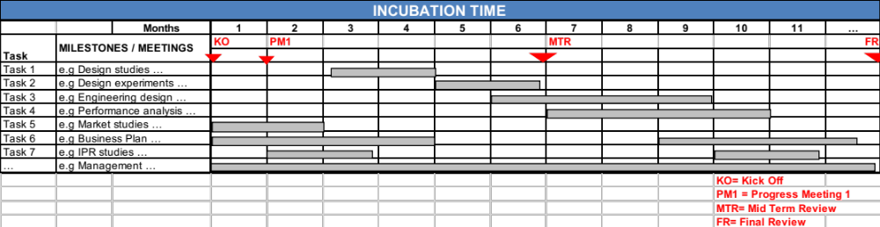

Fig.: Milestone Planning [example]

1.2 Task Descriptions

Writing Tips

[In this section a detailed description of each Task shall be provided. These Tasks are the core of the business incubation. Therefore, please include tasks both related to business, intellectual property, and technical activities. When you break down the overall business incubation activity, please limit yourself to a manageable structure.

Please note that the space connection should be a fundamental part of the proposed incubation activity. For a “downstream” activity this means that the Incubation Proposal should include clearly defined tasks about how the space based data, space technology, etc. is going to be integrated, further developed, or similarly, and how the related market will be developed. Similarly, for an “upstream” the Incubation Proposal should cover the related key technical and business activities.
Please provide task descriptions for all work you intend to do during incubation, not only for work related to using the incentive. If the tasks to carry out require additional resources (e.g. financing in addition to the incentive), please make this clear in the funding table below. Explain how all activities together contribute to the goal of your company.
For each Task, please provide a table containing a detailed description using the template below. Identify the responsible person, input, objective, and output. Use Sub-tasks to detail the activities further. One or several tasks shall contain outputs that qualifies as “deliverable” according to the Draft Incubation Contract, see also the separate section below.

The task descriptions, and especially the sub-tasks, should be detailed and specific enough for the evaluators of your proposal to understand in detail what activities will take place and how these contribute to the development of the technology and the business. They also serve as a way for the ESA BIC to monitor progress of your company and as a detailed work plan during incubation. Therefore, describe not only what you will do, but also what the intended result is. For development activities, describe how you are going to validate and verify the outcome.

In the costs overview, which also serves as an expenditure plan for the incentive and other sources of funding, explain which costs you expect to have and from which sources they are financed. In case you plan to use the incentive to pay for internal costs (provided this is allowed under the incubation contract), then also provide information on personnel category, number of hours, and internal hourly rates. You may do this by adding the requested information in column “Type of expense”, for example “Software engineer, X hours, EUR Y/h”.

Please respect any restrictions related to the ESA incentive as described in the draft incubation contract]

Text

Task # … [name]

Responsible: [name]

Inputs: [e.g. output of previous tasks, results of a tests campaign, reference of publication, …

Objective: [describe what should be achieved by the end of the task and define what a successful outcome is]

Sub-Tasks [describe in detail what work should be performed, e.g. which steps need to be taken in order to reach the objective]
- …
- …
- …

Costs

Sub-task | Type of expense/supplier/internal etc. | ESA incentive (EUR) | Local incentive (EUR) | Total of other sources (EUR)
Total (EUR)

Output: [e.g. Design Document, Software, Hardware prototype, Test Results, Market analysis, …]

Tab.: Task Description

1.3 Deliverables to the ESA BIC

Writing Tips

[Please provide a detailed description of which deliverables will be available and provided to the ESA BIC at the mandatory milestones PM1, MTR and FR. As a minimum, the following is required:
- PM1:
  - Finalised incubation proposal (including any updates agreed upon at the negotiation or subsequently)
  - Updated business plan including any changes made after applying to the ESA BIC
- MTR:
  - MTR report using the template to be provided
  - Updated business plan

- FR:
  - FR report using the template to be provided
  - Final business plan
  - Deliverable item

The ESA BIC may also request additional or other deliverables to be done.

Regarding “deliverable item”:
- The ESA BIC will discuss with successful applicants which “deliverable items” are suitable and can be agreed upon. Nevertheless, a proposal should be provided.
- This should be hardware, software, a prototype, demonstrations etc. that qualify as deliverable according to the Draft Incubation Contract.
- The ESA BIC will use this both for demonstration purposes and for verifying the use of incentive according to the incubation proposal (or as subsequently agreed).
- All deliverables should be agreed upon during contract negotiation and should be specified either in the incubation contract or in minutes of the negotiation.]

2. FINANCING and Funding Request

Writing Tips

[Please, describe in detail how the company will be financed during incubation. In particular, explain which sources of financing will be used until the company can generate sufficient revenues. Note any restrictions related to the ESA incentive and that most of this funding may be paid in terms after the costs have been made. If applicable, explain how the company’s own staff will be paid and from which sources.

In the table Funding Split below, please provide per task the estimated split of the costs into “External costs” (services or products provided by third parties) and “Internal costs”. Also indicate which sources will cover these costs.

The funding sources are normally divided into (see the draft incubation contact for details):

- The ESA incentive is limited to 30 kEUR. It can be used for any purpose linked with the objectives of the incubation. As a general rule, it has to be spent in the country of the ESA BIC where you are applying. This incentive does not have to be paid back. Please refer to the Draft Incubation Contract for more details.

- The local incentive is limited to 20 kEUR and is provided by local sources (so-called “local co-funding”), where specific funding rules may apply. For guidance, please contact the individual ESA BIC that you apply to before you submit the application.

- Other Sources: Please specify additional financial sources such as financial support provided by investors, etc. as well as company/entrepreneur own/self-funding. Please specify the other funding sources.

Please ensure that “Total Costs” match “Total Funding”.

In the column “Experts”, please provide a distribution of the Technical Support or IPR/Legal support requested across the defined tasks - on top of the incentive. Note, the number of support hours available per applicant may differ for individual ESA BICs. For guidance, please contact the ESA BIC that you apply to before you submit the application.

Please use the FUNDING table contained in the Excel file attached to this application and insert this below.]

Text

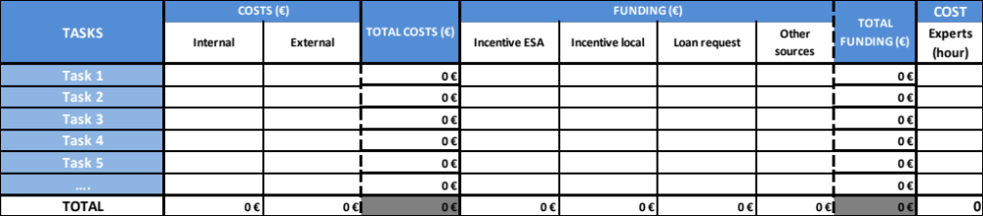

Tab.: Funding Split

3. Support Request

3.1 Technical and IPR Support

Writing Tips

[Please define in your own words, what type of Technical or Legal/IPR Support you request from the ESA BIC in order to develop your product/service. Technical support is typically provided as advisory support and is typically related to the use of space technology, data with space origin or methodologies developed within the space engineering domain. Sometimes access to facilities is available as technical support. IPR support is typically related to patents and other intellectual properties. Note, the support provider may differ for individual ESA BICs. For guidance, please contact the individual ESA BIC that you apply to before you submit the application.]

Text

3.2 Business Support

Writing Tips

[Please define in your own words, what type of Business Support you request from the ESA BIC in order to establish and grow your company. Such support is typically provided through coaching and training. Note, the support provider may differ for individual ESA BICs as well as the number of support hours available per applicant. For guidance, please contact the individual ESA BIC that you apply for before you submit the application.]

Text

3.3 Office Support

Writing Tips

[Please define the number of desk places and further requirements such as laboratory space. Please note, that you will typically be required to rent office or lab space, while common facilities at the ESA BIC may be provided free of charge during incubation, such as meeting rooms. For guidance, please contact the individual ESA BIC that you apply to before you submit the application.]

Text

The following exceptions apply to the use of the ESA incentive and the Incubation Boost funding. This may not be used to pay for A) Founders/entrepreneurs own wages, B) Office rental costs or incubator service fees, C) return on capital, interests, losses, debts or similar.

